Analysis of Algorithms

Running time
Most algorithms transform input objects into output objects.
- The running time of an algorithm typically grows with the input size.
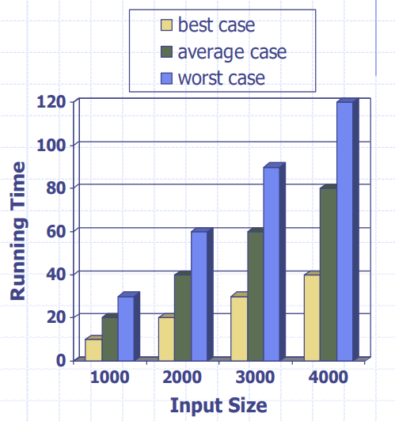
- Analysis of algorithms:
  - to understand how the running time grows with the input size.
- Average case running time is often difficult to determine.
- We focus on the worst case running time.
  - Easier to analyse
  - Crucial for applications such as games, finance and robotics.

Experimental studies
- Write a program implementing a given algorithm.
- Run the program with inputs of varying sizes and composition.
- Use a method like System.currentTimeMillis() to measure the actual running time.
- Plot the results.
- Do the same for other algorithm(s) and compare.

Limitations of experiments
- It is necessary to implement the algorithm, which may be difficult (costly).
- We may have a number of potential algorithms for a given task, but we would like to implement only one – the best one.
- Results may not be indicative of the running time on other inputs not included in the experiment
- In order to compare two algorithms, the same hardware and software environments must be used.

Theoretical analysis
- Uses a high-level description of the algorithm (pseudocode) instead of an implementation.
- Takes into account all possible inputs.
- Allows us to evaluate the speed of an algorithm independent of a hardware/software environment.
- Characterizes running time of an algorithm as a function of the input size, n:
  - For a given algorithm, determine a function f(n) that characterizes the (worst-case) running time of this algorithm as a function of the input size n.

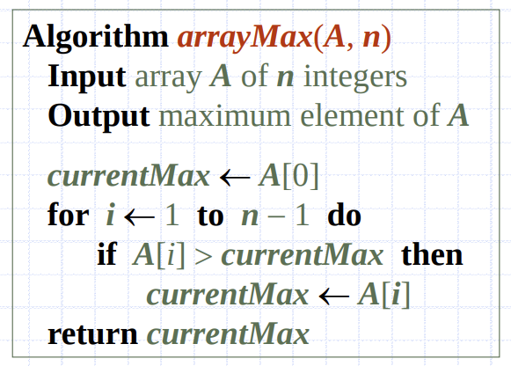
Pseudocode
- More structured than English prose
- Less detailed than a program
- Preferred notation for describing algorithms
- Hides program design issues.

Pseudocode details
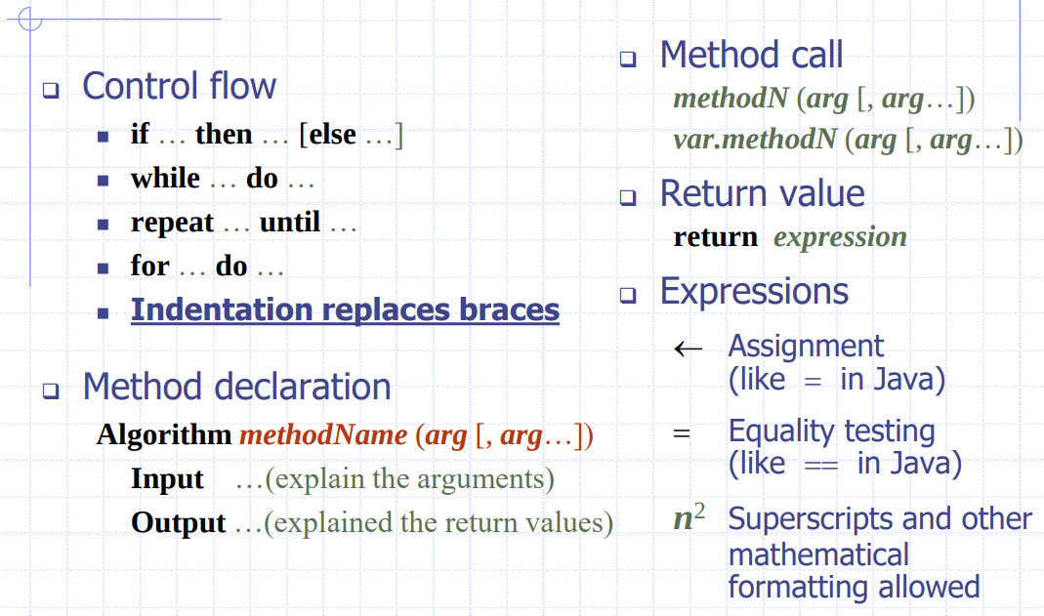

The random access machine model
We assume it has:
- A CPU
- A memory: a potentially unbounded bank of memory cells, each of which can hold an arbitrary number or character. Memory cells are numbered.
- Unit time
  - Each CPU operation takes unit time.
  - Accessing any cell in memory takes unit time.
- Approximation of real computers but mostly sufficient for predicting real running times.

Primitive Operations
These are basic computations performed by an algorithm.
- Identifiable in pseudocode.
- Largely independent from the programming language.
- Exact definition not important.
- Assumed to take a constant amount of time in the RAM model.
- e.g.: Assigning a value to a variable, comparing two numbers, evaluation an expression, etc.

Counting primitive operations
The function f(n), which characterizes the running time of a given algorithm: the maximum number of primitive operations executed by this algorithm, as a function of the input size.
- For a given n, f(n) is the maximum number of primitive operations executed by this program, for any input of size n.
- We can determine this maximum number of primitive operations by inspecting the pseudocode of the algorithm.
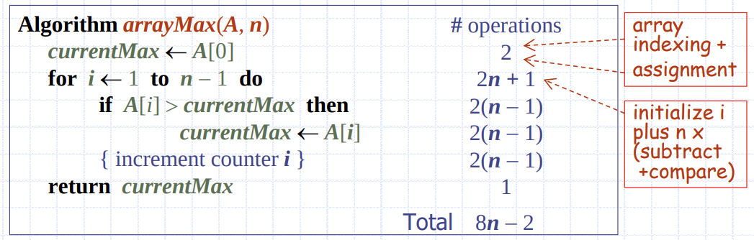

Estimating running time
Algorithm arrayMax executes 8n – 2 primitive operations in the worst case.
- Define:
  - a = the time taken by the fastest primitive operation
  - b = the time taken by the slowest primitive operation
Let T(n) be worst-case time of arrayMax. Then:
(8a)n – 2a = a(8n – 2) <= T(n) <= b(8n – 2) = (8b)n – 2b
Hence, the running time T(n) is bounded by two linear functions of the argument n.
Input size n → 10n : running time T(10n) ≈ 10 x T(n)

Growth rate of running time
Changing the hardware/software environment…
- affects T(n) by a constant factor, but
- does not alter the growth rate of T(n)
The linear growth rate of the running time T(n) is an intrinsic property of algorithm arrayMax, and is independent of hardware, implementation and computing environment.

Why growth rate matters
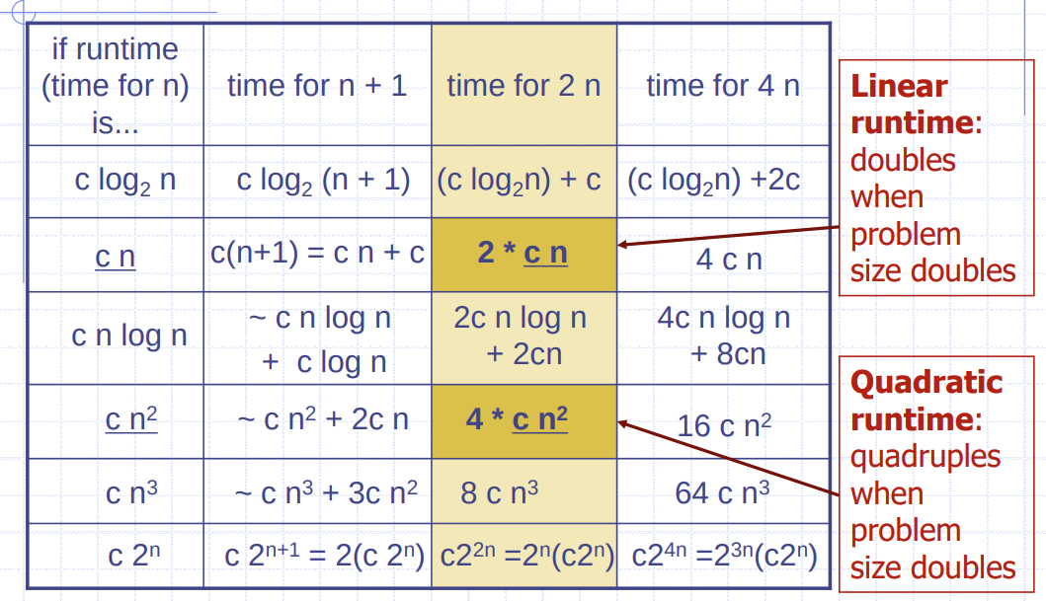

Seven important functions
- Seven functions that often appear in algorithm analysis:
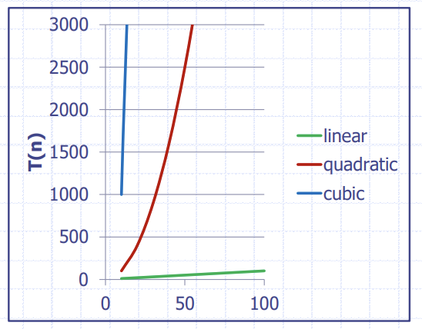
  - Constant: ~1
  - Logarithmic: ~log n
  - Linear: ~n
  - N-Log-N: ~n log n
  - Quadratic: ~n²
  - Cubic: ~n³
  - Exponential: ~2^{n}
It’s not easy to compare these functions using plots with ‘normal’ (linear) scale.

Comparison of two algorithms
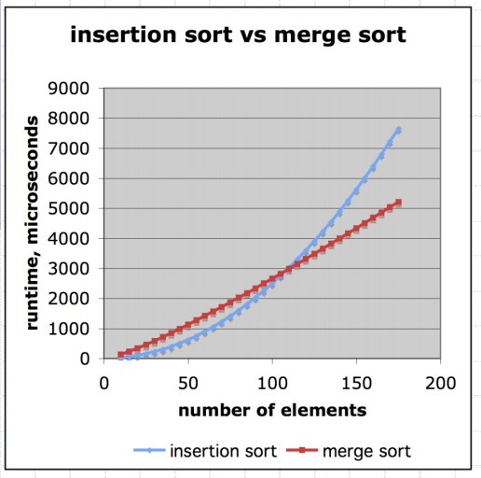
Insertion sort is n² / 4
Merge sort is 5 n log_{n} n
To sort one million items:
- Insertion sort takes roughly 70 hours
- Merge sort takes roughly 100 seconds
On a slow machine, but if it’s on a faster machine, say 100x faster, then it’s 40 minutes versus 1 second.

Constant factors & lower terms
The growth rate is not affected by:
- constant factors
- lower-order terms
e.g.:
- 10²n + 10⁵ is a linear function.
- 10⁵n² + 10⁸n is a quadratic function.

Big-oh notation
Given functions f(n)and g(n) we say that
f(n) is O(g(n))
if there are positive constants c and n₀ such that
f(n) <= c x g(n), for n >= n₀
Example: 2n + 10 is O(n)

Example
7n – 2
- 7n - 2 is O(n)
  - need c > 0 and n₀ >= 1 such that 7n – 2 <= c n, for n >= n₀
  - this is true for c = 7 and n₀ = 1
3n³ + 20n² + 5
- this is O(n³)
  - need c > 0 and n₀ >= 1 such that 3n³ + 20n² + 5 <= c n³, for n >= n₀
  - this is true for c = 4 and n₀ = 21
3 log n + 5
- this is O(log n)
  - need c > 0 and n₀ >= 1 such that 3 log n + 5 <= c log n, for n >= n₀
  - this is true for c = 8 and n₀ = 2
In all examples, other values of c and n₀ could also work!

Counter example
The function n² is not O(n).
- n² <= cn
for some c and all n >= n₀
- n <= c
for some c and all n >= n₀
- This cannot be satisfied since c must be a constant.

Big-oh and growth rate
The big-Oh notation gives an upper bound on the growth rate of a function.
- The statement f(n) is O(g(n)) means that the growth rate of f(n) is not greater than the growth rate of g(n).
- We can use the big-Oh notation to rank functions according to their growth rate.
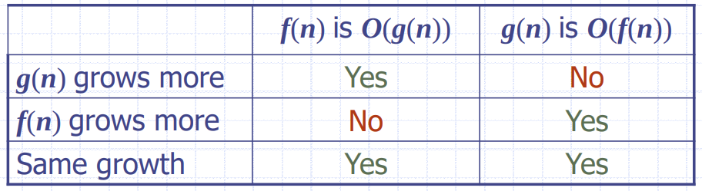

Big-oh rules
If f(n) is a polynomial of degree d, then f(n) is O(n^{d}), i.e.:
- Drop the lower-order terms
- Drop the constant factor in the highest order term
- e.g.: 5n⁴ + 20n³ – 7n + 13 is O(n⁴)
Use the smallest possible class of functions
- Say ‘2n is O(n)’ instead of ‘2n is O(n²)’
Use the simplest expression of the class
- Say ‘3n + 5 is O(n)’ instead of ‘3n + 5 is O(3n)’
We also write, e.g., ‘3n + 5 = O(n)’

Asymptotic algorithm analysis
The asymptotic analysis of an algorithm determines the running time in big-Oh notation (or its ‘relatives’)
- To perform the asymptotic analysis:
  - We find the worst case number of primitive operations executed as a function of the input size.
  - We don’t need this function exactly, we only want to express it using big-Oh notation.
Example:
- We determine that algorithm arrayMax executes at most 8n – 2 primitive operations.
- We say that algorithm arrayMax “runs in O(n) time.”
- Since constant factors and lower-order terms are eventually dropped anyhow, we can disregard them when counting primitive operations.

Computing prefix averages
We further illustrate asymptotic analysis with two algorithms for prefix averages.
- The i-th prefix average of an array X is the average of the first (i + 1) elements of X:
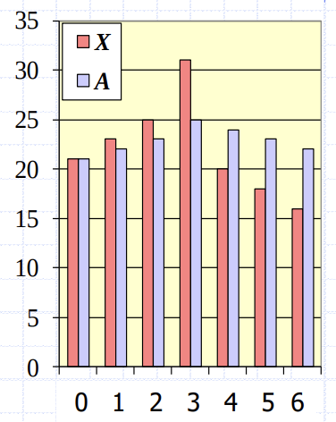
A[i] = (X[0] + X[1] + … + X[i])/(i + 1)
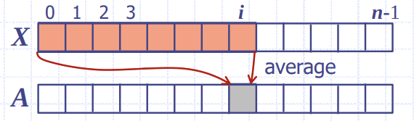

- Computing the array A of prefix averages of another array X has applications in financial analysis.

Prefix averages (quadratic)
The following algorithm computes prefix averages in quadratic time by directly applying the definition:
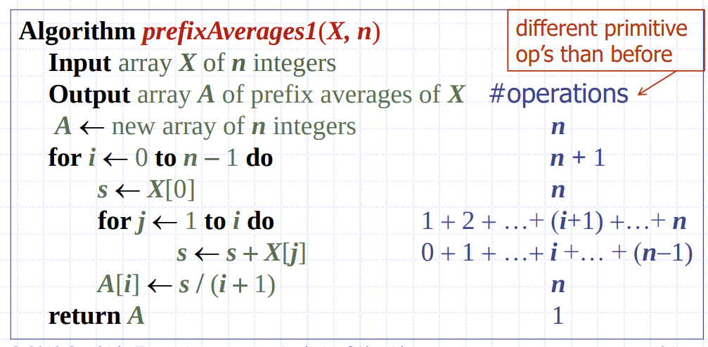

Arithmetic progression
- The running time of prefixAverages1 is
2(1 + 2 + … + n) + 3n + 2
= O(1 + 2 + … + n)
- The sum of the first n integers is
1 + 2 + … + n = n(n + 1) / 2
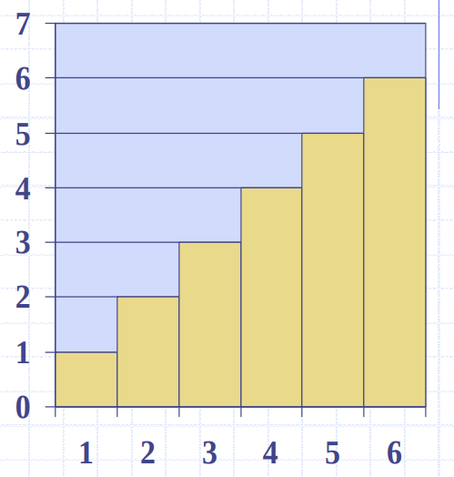
- A simple visual proof of this fact is →
- Thus algorithm prefixAverages1 runs in
O(n(n+1)/2) = O(n²) time: quadratic algorithm

Prefix averages (linear)
The following algorithm computes prefix averages in linear time by keeping a running sum.
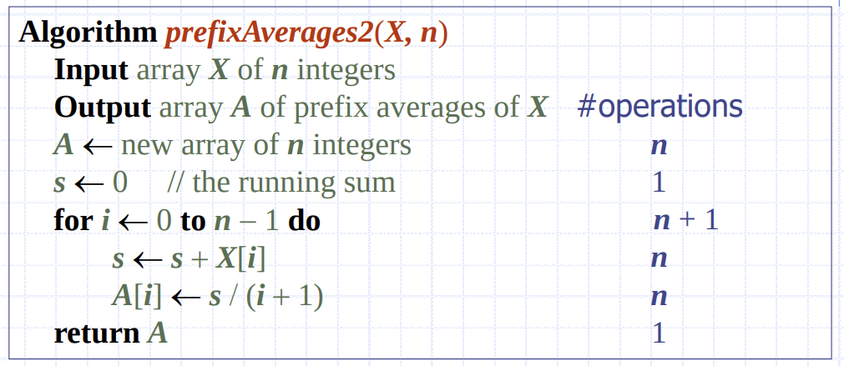
Algorithm prefixAverages2 runs in O(n) time.

Big-oh and relatives
Big-Oh
- f(n) is O(g(n)) if, asymptotically, f(n) is less than or equal to g(n)
- We want n to be the smallest possible value.
Big-Omega
- f(n) is Ω(g(n)) if, asymptotically, f(n) is greater than or equal to g(n)
- We want n to be the largest possible value.
Big-Theta
- f(n) is Θ(g(n)) if, asymptotically, f(n) is equal to g(n).
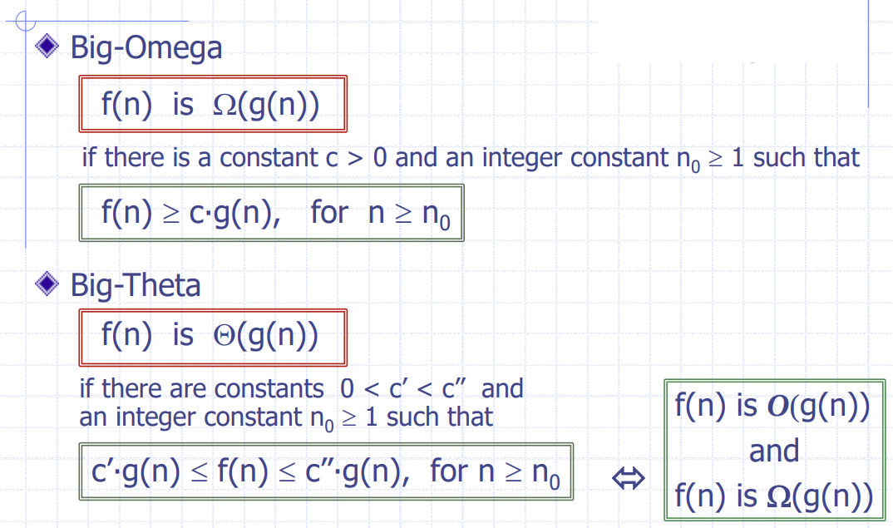

Examples
